Keep the unit without connecting any Utility or batteries, remove the PCB
Please use the multimeter to measure the diode voltage the main board element.
Please write down your measured values

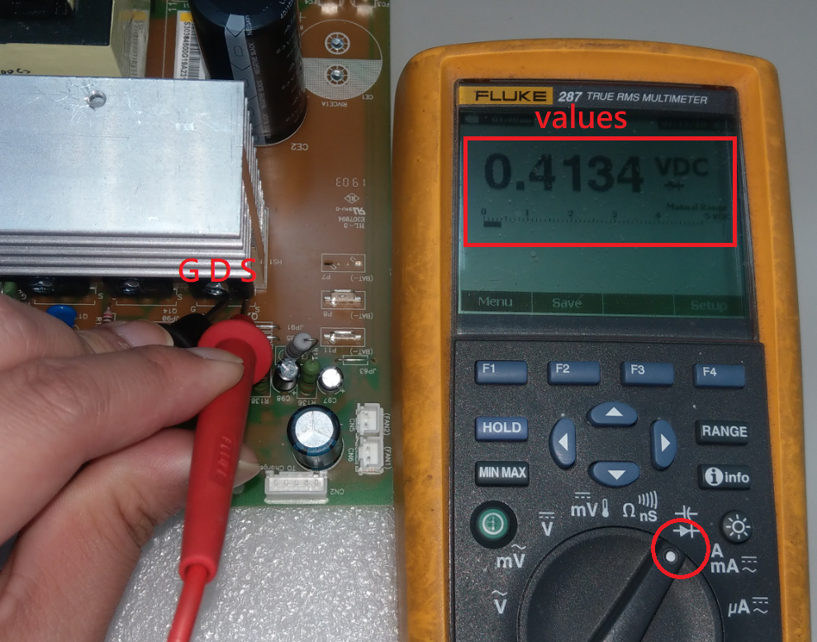

Measure point:
- 1. Converter MOSFET& IGBT check(Main board)
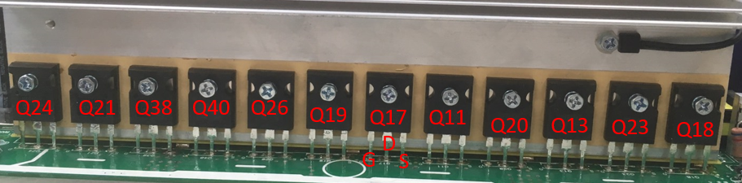
Parts | Attribute | Reference values | Failure status
ALL | Diode | SD: 0.556V  DS: OL

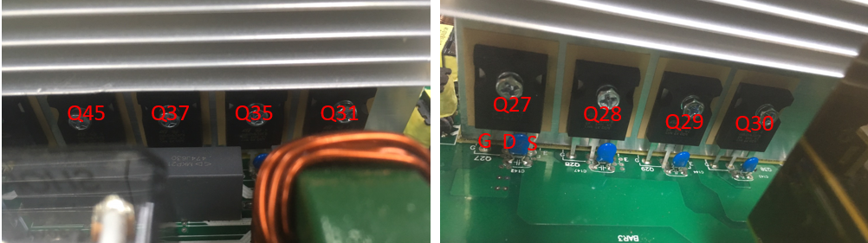

Parts | Attribute | Reference values | Failure status
ALL | Diode | EC: 0.358V  CE: OL

- 2.BUCK IGBT & Diode(Main board)

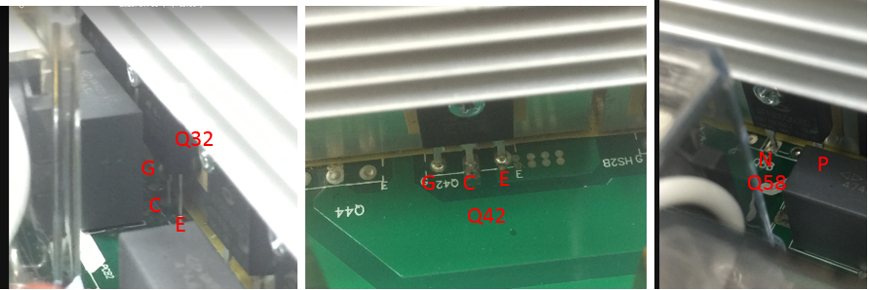

Parts | Attribute | Reference values | Failure status
Q32/Q42 | Diode | CE: OL  EC: 0.39V | Short or explosion
Q58 | Diode | + to -: 0.39V  - to +: OL | Short or explosion
- 3.Inverter IGBT (Main board)

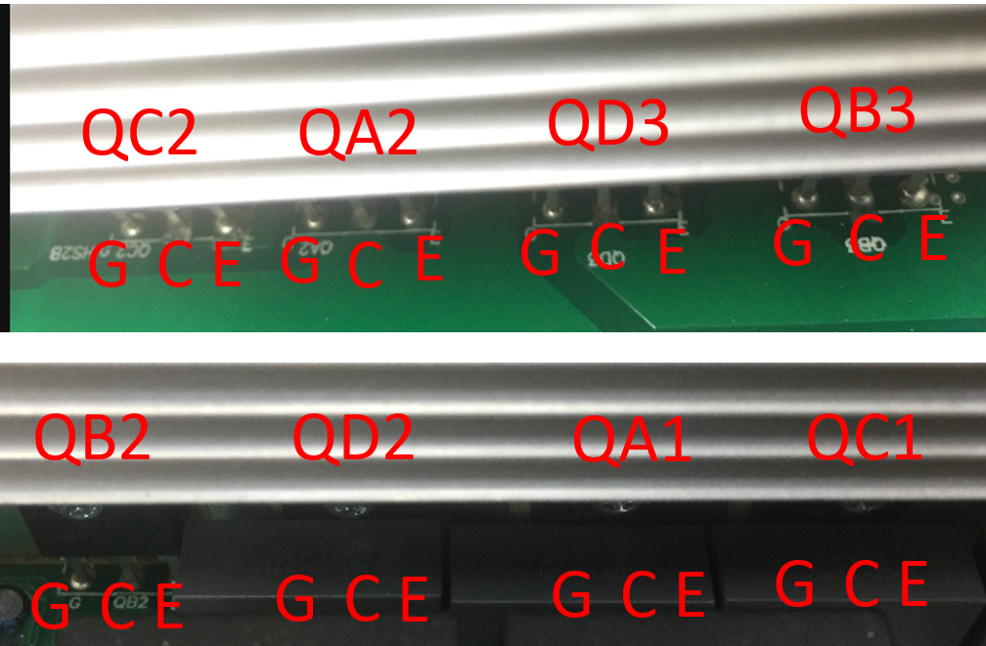
Parts | Attribute | Reference values | Failure status
ALL | Diode | EC: 0.378V  CE: OL | Short or explosion

- 4.BUS Soft and SPS (MOSFET &Diode)
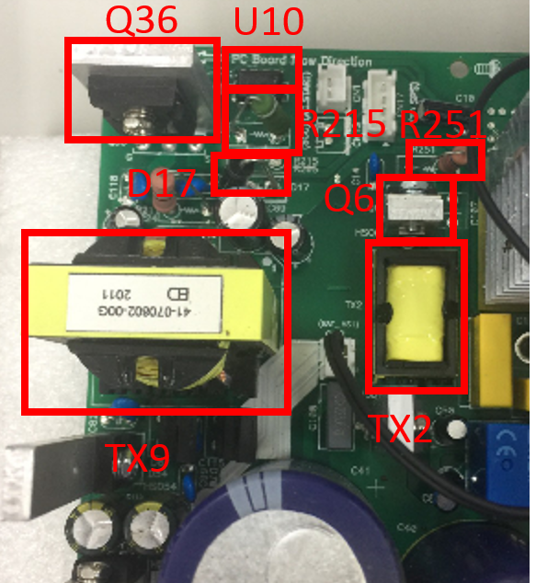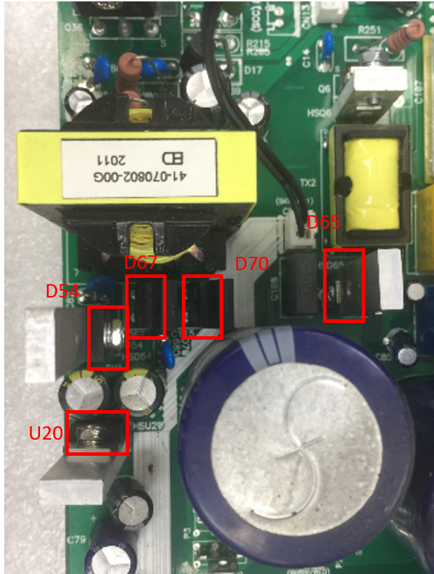
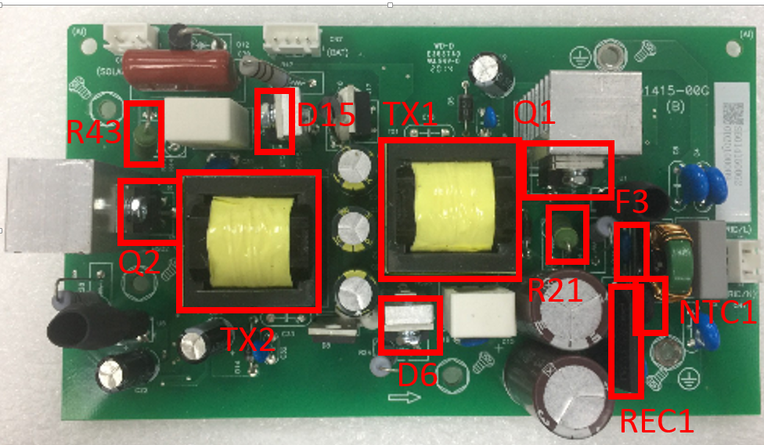

Parts | Attribute | Reference values | Failure status
Q36 | Diode | SD: 0.46V  SG: 0.65V | Short or explosion
Q6 | Diode | SD: 0.46V  SG: 0.29V | Short or explosion
D54 | Diode | + to -: 0.384V  - to +: OL | Short or explosion
D65 | Diode | + to -: 0.448V  - to +: OL | Short or explosion
Q1, Q2 | Diode | SD: 0.417V  SG: 0.301V | Short or explosion
D5,D6 | Diode | + to -: 0.428V  - to +: OL | Short or explosion

- 7.MPPT Boost MOSFET &Diode (MPPT board)
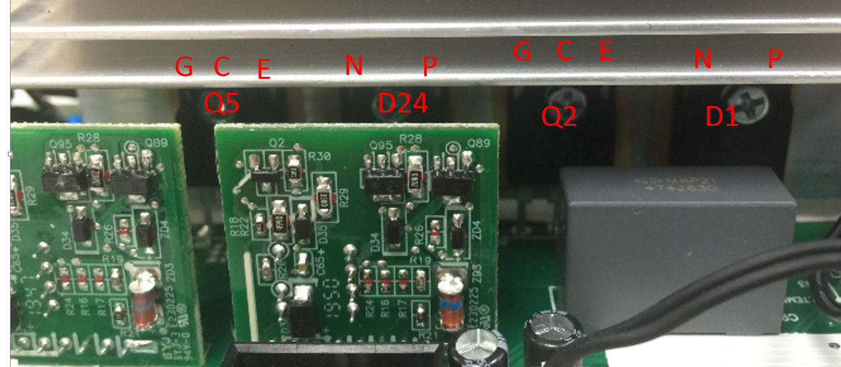

Parts | Attribute | Reference values | Failure status
Q2, Q5 |  |  | Short or explosion
Q2, Q5 | Diode | EC: 0.382V  CE: OL | Short or explosion
D1,D24 | Diode | + to -: 0.381V  - to +: OL | Short or explosion
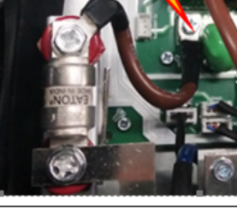
Parts | Attribute | Reference values | Failure status
AC Fuse |  |  | Open
AC Fuse | Resistor | 0R | Open

